World HTLV Day November 10th 2023: Remember to test

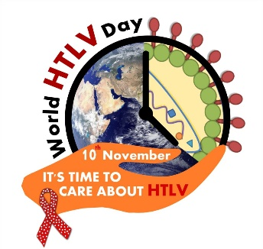 htlv.net

World HTLV Day 2023, on November 10th is an opportunity to increase awareness of this preventable viral infection, which can cause an aggressive cancer of the blood or inflammation of the spinal cord.
HTLV was the first oncogenic human retrovirus to be discovered.
In the UK, an estimated 36,000 people have the infection. Globally, at least 5-10 million are infected. However, these numbers are an underestimate, as most parts of the world, including the UK, do not routinely screen for this virus.
Whilst it is found clustered in certain parts of the world, it can infect anyone. HTLV can be detected by a simple blood test.
It is transmitted, like other blood borne viruses, via breastmilk, sex, contaminated blood and equipment. Unlike other blood borne viruses, it is not screened for routinely in antenatal clinics or sexual health clinics. There is government guidance in place for screening the migrant population, in particular women.
The majority of infection is undetected in the UK. An undetected virus will continue to spread and this is reflected by an increase in the estimated prevalence in England and Wales. Condom use and monitored breastfeeding can prevent transmission. We cannot eliminate an undetected virus.

This blood borne virus causes 2 devastating complications:
Adult T cell lymphoma/leukaemia (ATL)
HTLV associated myelopathy (HAM), which is a systemic inflammatory condition

However, it is also associated with a variety of different conditions, and thus can present to a variety of clinical specialists: haematology, neurology, urology, ophthalmology, rheumatology, endocrinology, HIV and infectious disease. Have you considered HTLV infection in your patient group?
- Causal Association demonstrated with disease |  | - Higher prevalence and/or worse outcome
- Malignancy | - Inflammatory | - Co-infection
- Adult T cell leukaemia/lymphoma | - Myelopathy | - Strongyloides stercoralis
 | - Encephalitis | - Mycobacterium tuberculosis
 | - Kerato-conjunctivitis sicca | - HIV
 | - Uveitis | - Mycobacterium leprae
 | - Thyroiditis | - Syphilis
 | - Bronchiectasis | - Chlamydia trachomatis
 | - (Infective) Dermatitis | - Human papillomavirus
 | - Seronegative arthritis | - Schistosoma mansoni
 | - Polymyositis

Occupational Needlestick Injury at Imperial College Healthcare NHS Trust – all source patients to be tested for HTLV infection, and recipients considered for post exposure prophylaxis against HTLV with Truvada and Raltegravir in accordance with Trust guidelines.

